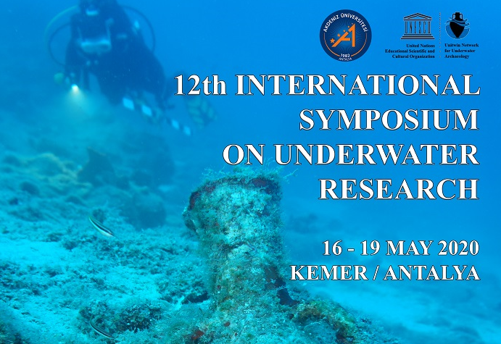
12th ISUR ON-LINE PROGRAM
May 16, 2020 Saturday
09.30 – 17.00 (UTC + 3)
Live at YouTube, Instagram and Facebook (Links are below of the program)

09.30 Opening of 19th IKUD (International Kemer Underwater Days) and 12th ISUR (International Symposium of Underwater Research) ON-LINE

Opening Speeches

09.30 – 09. 40 Welcome Messages of Necati Topaloğlu (Mayor of Kemer), Volkan Yorulmaz (KETAV), Aydın Aytuğ (AAD) and Hakan Öniz (Akdeniz University)

09.40 Prof. Dr. Tuncer Demir (Director of Akdeniz University, Mediterranean Civilizations Research Institute)

09.45 Prof. Dr. Ralph O.Schill (President of CMAS Scientific Committee)

09.50 Prof. Dr. Alessandro Marroni (President of DAN Europe)

Sessions of 12th ISUR (On-Line for the speakers Microsoft TEAMS and SKYPE)

SESSION 1 (10.00 – 10.59)
Moderator: Assoc.Prof.Dr. Hakan Öniz
10.00 Ahmet BİLİR - The Underwater Surveys of Çamlimanı Bay
10.12 Asuman BALDIRAN - Underwater Works on Iasos Harbors
10.24 Barış GÜR - Contributions of Underwater Archaeology in The Evaluation of Mycenaean Commercial Relations
10.36 Bartosz KONTNY- Roman Period and Medieval Sacrificial Site From Lake Lubanowo (Nw Poland)
  - Bill JEFFERY - Tidal Stone ‐Walled Fish Weırs of Yap, Federated States Micronesia and Their Role in Marine Ecological Conservation

SESSION 2 (11.00 – 11.59)
Moderator: Assoc.Prof.Dr. Sengul Aydıngun

11.00-A.A. BUKATOV, V.V. VARLAGIN, Y.G. TKACHENKO, S.A. KHOKHLOV Research of The Flooded Ruins in Port Area of City Tauric Chersonese Using Methods of Aerial and Underwater Photogrammetry

11.12 Burçin GÜRBÜZ, Ahmet DENKER, Burcu DOĞRU - Digital Reconstruction of the Archaeological Shipwrecks

11.24 Bülent GÖZCELİOĞLU - Some Marine Creatures Obtained From the Antarctic Sea Environment During the Turkish Antarctic National Science Expedition (TAE-2- 2018)
  - Emre ERDAN, Fatih ERSAN, Kubilay GÜÇLÜ - Archaeology, Physics and Chemistry; A Technique Used by Mediterranean Sponge Divers from Ancient Times to The Ottoman Period: Spraying and Pouring Olive Oil

  - Enrique ARAGON, Andrea SANZ - The Formentera Island Project Maritime Cultural Heritage Research and Conservation

SESSION 3 (12.00 – 12.59)
Moderator : Prof.Dr. Levent Cavas

12.00 S. FAZLULLIN, S. KHOKHLOV, Y. TKACHENKO, M. BARDASHOV, O. PLATONOVA, I. GORLOV - Underwater Research in Lake Onega, The Kizhi Museum Area.

  - Haldun AYDINGÜN, Şengül AYDINGÜN, Hakan ÖNİZ - Discovery of the Antique Harbors West of Istanbul
  - Kemal ÇİBUK , Rıdvan GÖLCÜK - The Impact of The Industrial Pollution and Rapid Urbanization on The Number and Diversity of Amphorae in The Museums: The Case of İzmit Gulf

  - Krzysztof ULANOWSKI - Earthly, Water and Underwater Meetings of The Phoenicians and The Greeks. Mythological and Religious Ways of Transmission in The East of Mediterranean.
12.48 Laura CARRILLO, Nicolas CIARLO, Andres ZUCCOLOTTO, Josue GUZMAN -Ghosts Of The Caribbean. Recent Research On El Angel Shipwreck: A 19th Century Composite-Hull, Sailing Merchantman in Chinchorro Bank, Mexico

SESSION 4 (13.00 – 13.59)
Moderator : Dr. Haldun Aydıngun

13.00 Levent ÇAVAŞ, Tugbay İNAN - Antifouling Paints and Water Sports
13.12 Lynn B. HARRIS - Maritime Heritage at Risk: Lighthouses Shipwrecks, and Deserted Towns
13.24 Levent ÇAVAŞ, Yeşim Yılmaz ABEŞKA - Biosynthesis of silver nanoparticles by using invasive Caulerpa cylindracea Sonder
13.36 Lynn B. HARRIS - Sick Bays of the South Atlantic: Strategies For Countering Epidemics in Ports, Anchorages and on Islands during the 19th Century
  - Magdalena NOWAKOWSKA, Malgorzata MILESZCZYK - Lake Grid Dwellings Of The West Balt Barrow Culture – The Story Of Research And Researchers. The Case Of Lake Piłakno (Ne Poland)

SESSION 5 (14.00 – 15.00)
Moderator : Drt. Ceyda Oztosun

14.00-Michele STEFANILE - Submerged Harbors In the Gulf Of Naples. A Short Update on The Basis of Recent Underwater Archaeology Researches.
14.12-Musa TOKMAK , Murat DAL - Types Of Degradation Observed in Underwater Stone Artifacts
14.24-Mustafa ŞAHİN - Underwater Excavation At The Bazilikal Church in İznik Lake – 2019
  - -I.R. NIKOLAEV - The Impact of Natural and Social Factors On The Perception Of An Underwater Parks: A Study Of Russian Recreational Divers.

14.48-Paola PUPPO - Shipwreck Cargoes in The Balearic Islands: The Hellenistic Reliefware as Indicator of Maritime Trades in The Western Mediterranean.

SESSION 6 (15.00 – 15.24)
Moderator : Assoc.Prof. Dr. Hakan Oniz

15.00- A. BYKOVA, M. DENISOVA, S. FAZLULLIN – " The world of infinity. Andre laban" exhibition project about the history of underwater research and the world-famous aquanaut Andre Laban.
15.12- : Maria Ayça ATEŞ - Objects of Maritime and Underwater Cultural Heritage of Cyprus Island.
15.24- Ayse GAZIHAN - Blue Growth Initiatives in the European Seas

15.36 - Victor V. LEBEDINSKI, Julia A. PRONINA - Deep-sea research of the shipwrecks of the XI-XIIth centuries AD in the waters of the administrative territory of Sevastopol

15.48- Şahin ÖZEN – Training System of Underwater Cultural Heritage in Turkey

16.00-Closing Remarks by Assoc.Prof.Dr. Şahin Özen (President of Turkish Underwater Federation) and Hakan Öniz

Youtube: https://www.youtube.com/channel/UCWOyHFerGVb615073BZFK-Q?view_as=subscriber

Facebook: https://www.facebook.com/kemer.fest.31

Instagram: https://www.instagram.com/kemerfest.ikud/ @kemerfest.ikud

